Project – Low Level Design
on
IaC Provisioning for Non-Profit Support System

  - Course Name: DevOps

Institution Name: Medicaps University – Datagami Skill Based Course

Submitted by:
Sr no | Student Name | Enrolment Number
1. | Ananya Subramanya Rao | EN22CS301120
2. | Anirudh Vyas | EN22CS301131
3. | Anushka Kashyap | EN22CS301180
4. | Atharv Chaturvedi | EN22CS301228
5. | Harshit Panchal | EN23CS3L1010

Group Name: Group 03D2
Project Number: DO-15
Industry Mentor Name: Vaibhav Sir
University Mentor Name: Prof. Akshay Saxena
Academic Year: 2026

Table of Contents
- Introduction
  - Scope of the document
  - Intended Audience
  - System overview
- System Design
  - Application Design
  - Process Flow
  - Information Flow
  - Components Design
  - Key Design Considerations
  - API Catalogue.
- References

- Introduction

The SupportHub Low-Level Design (LLD) document provides a detailed technical description of the infrastructure, architecture, and implementation decisions made for the DevOps project DO-15. This document serves as the technical blueprint for the IaC Provisioning for Non-Profit Support System, So our web app is SupportHub — an AI-Powered Microservices Platform for Non-Profit Support Operations system built to automate the provisioning and deployment of two non-profit support applications: TriageAgent and QuizBot.
Problem Statement
Automate the provisioning of infrastructure for a Non-Profit system using Infrastructure as Code (IaC) tools like Terraform or Ansible. The project involves script-based deployment of local Docker environments or cloud instances (e.g., AWS), including the automated installation of core dependencies such as Terraform or Ansible. This approach eliminates manual configuration errors and enables repeatable, scalable environment setup.
Project Objectives
- Real-Time Classification: Classify every message by urgency (Critical /High /Normal/Low) and intent (Donation/Volunteer/Complaint/etc.) using Gemini API.
- Named Entity Recognition: Extract names, dates, amounts, emails, receipt IDs, and case numbers using hybrid spaCy + LLM approach.
- Draft Response Generation: Generate professional, contextual email responses tailored to message content and urgency.
- Intelligent Routing — Auto-route messages to the correct department.
- Human-in-the-Loop: Admin dashboard to review, approve, or reject AI responses.
- Analytics: Real-time insights on urgency trends, intent distribution, and system performance.
- Production-Grade Reliability: Secure, scalable system with JWT auth, rate limiting, retry logic, and Firebase infrastructure.

  - Scope of the document

This Low-Level Design (LLD) document provides a detailed technical specification for the TriageAgent system — An AI-Powered Communication System for Non-Profit Organizations. It translates the high-level architecture into concrete, implementable components, covering module design, API contracts, data models, class descriptions, user flow, data flow, and key design decisions. The document covers:
- Overall system architecture and component interactions
- Technology stack and design decisions
- Data flow between frontend, backend, and third-party services
- Integration design for AI (Google Gemini), AI Agents, and Firebase
- Security, authentication, and API design at a high level
This document serves as the primary technical reference for developers, reviewers, and evaluators of the project. It covers both the backend (FastAPI + AI agents) and the frontend (React 18) subsystems.

  - Intended Audience

- Non-Profit Organization Staff The primary users. Staff members who receive and respond to incoming communications daily — donation queries, volunteer inquiries, complaints, and partnership requests. They use the admin dashboard to review AI-generated classifications and approve or reject draft responses.
- Non-Profit Administrators / Managers Team leads and managers who monitor the analytics dashboard to track message volume, urgency distribution, response times, and team performance metrics.
- Department Teams Specific teams (Donations, Volunteers, Support, Partnerships) who receive routed messages assigned to them based on intent classification.

  - System overview

TriageAgent is a production-grade, AI-powered reactive triage system built for Non-Profit organizations. It automates the processing of incoming communications by performing four core operations in sequence:
# | Operation | Technology Used | Output
1 | Message Classification | Gemini 2.5 Flash (JSON mode, temp=0.3) | urgency + intent + confidence + reasoning
2 | Named Entity Recognition | spaCy en_core_web_sm + Gemini LLM (hybrid) | persons, dates, amounts, emails, receipt IDs
3 | Draft Response Generation | Gemini 2.5 Flash (temp=0.7, max_tokens=2000) | Full email draft with Subject line + body
4 | Intelligent Routing | Router Agent (enum lookups) | Department + priority level 1–4
The system processes each message in 5–10 seconds, reducing manual triage time from 15–20 minutes to under 1 minute — a 10–20× improvement in resolution speed. All results are stored in Firebase Firestore and reviewed via a React 18 admin dashboard.

- System Design
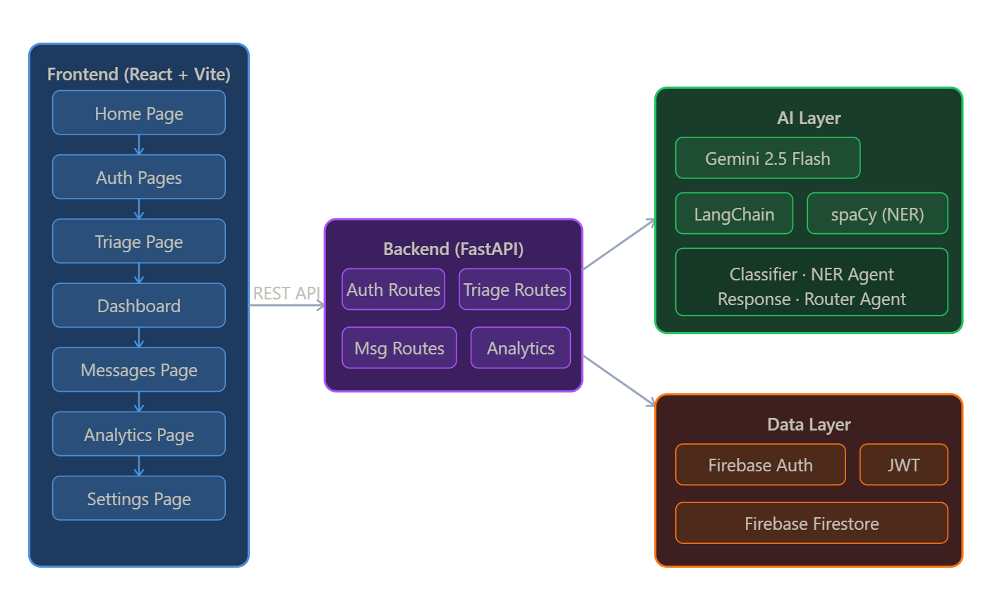

  - Application Design

The TriageAgent follows a 3-Tier Client-Server architecture with a Multi-Agent AI layer embedded in the backend tier. The system is organized into four distinct layers with strict top-down communication — no layer bypasses another.
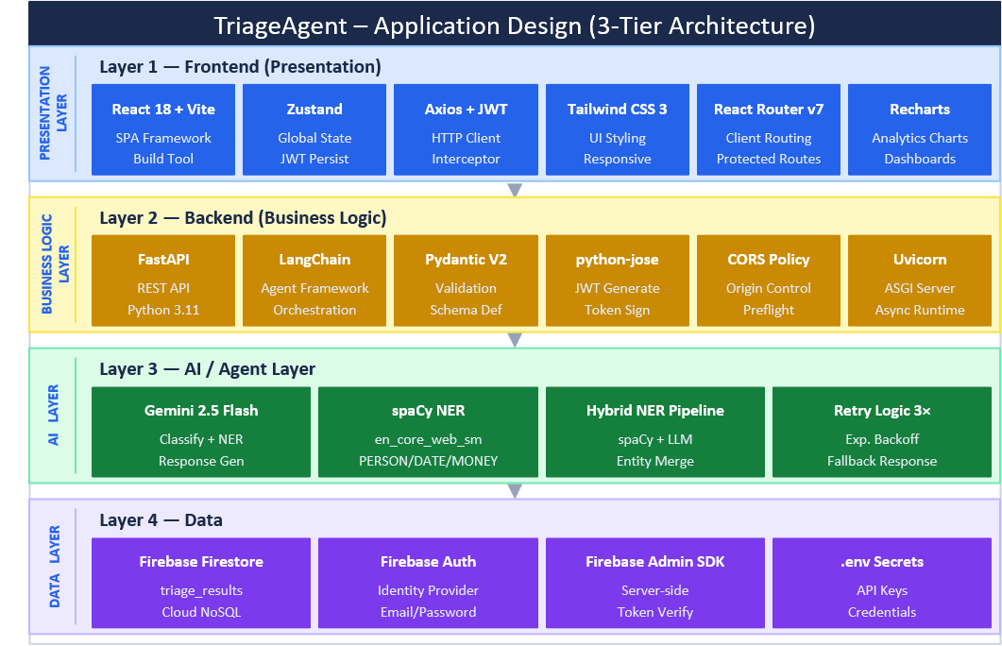

  - Process Flow

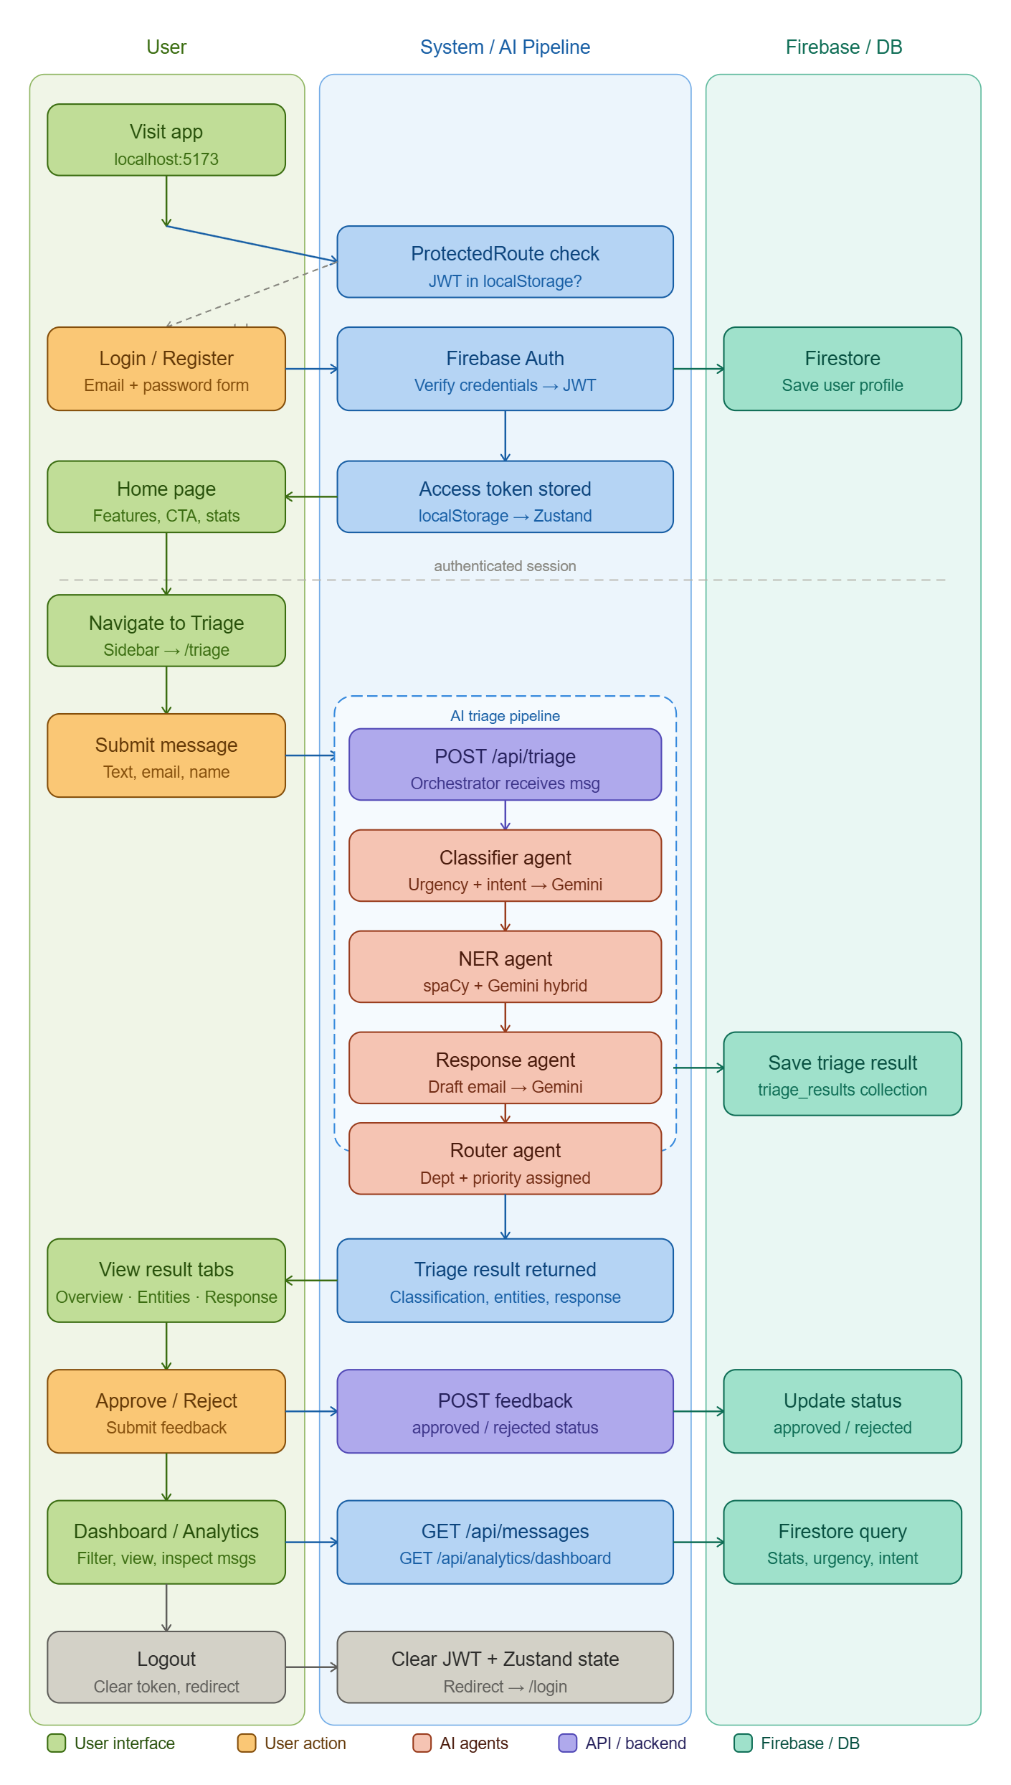

  - Information Flow
    - Data Flow Diagram
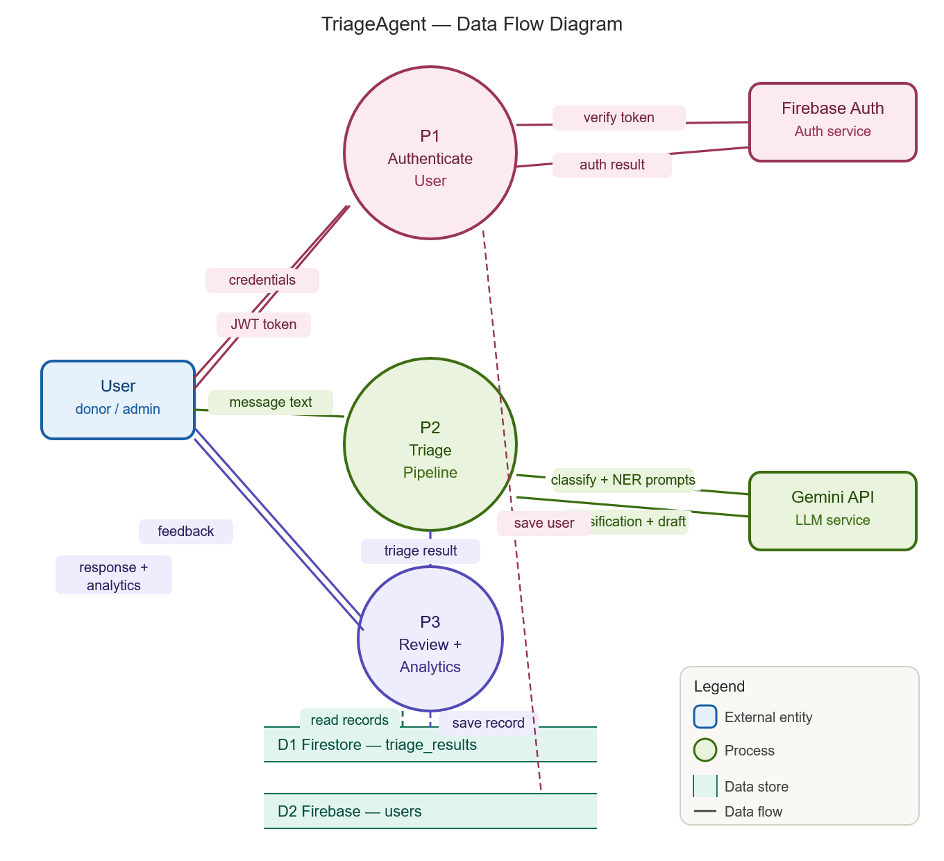
    - Data Entity Relationship Diagram

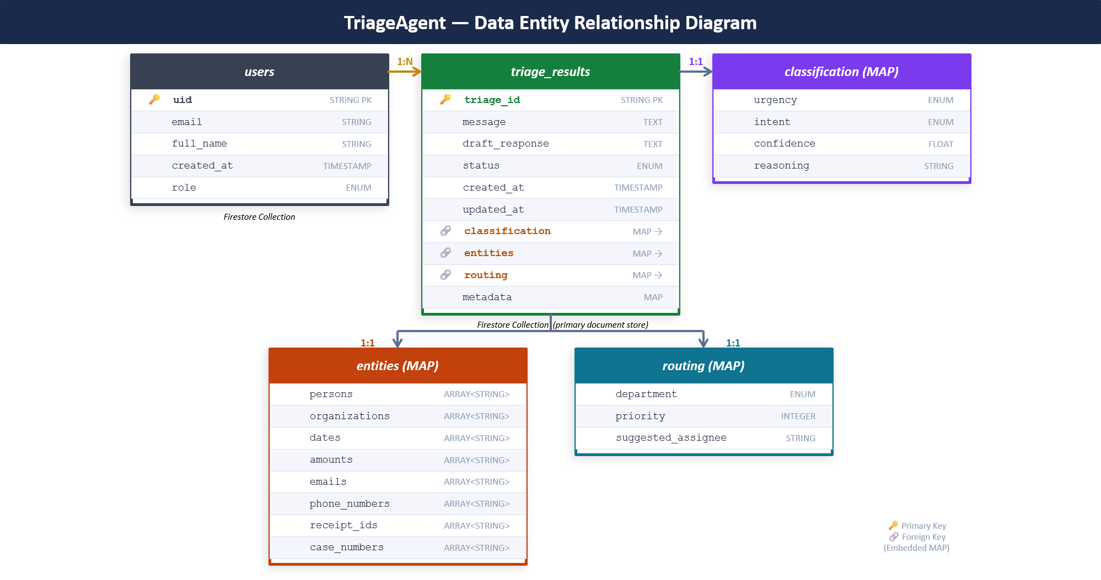

    - Class Diagram

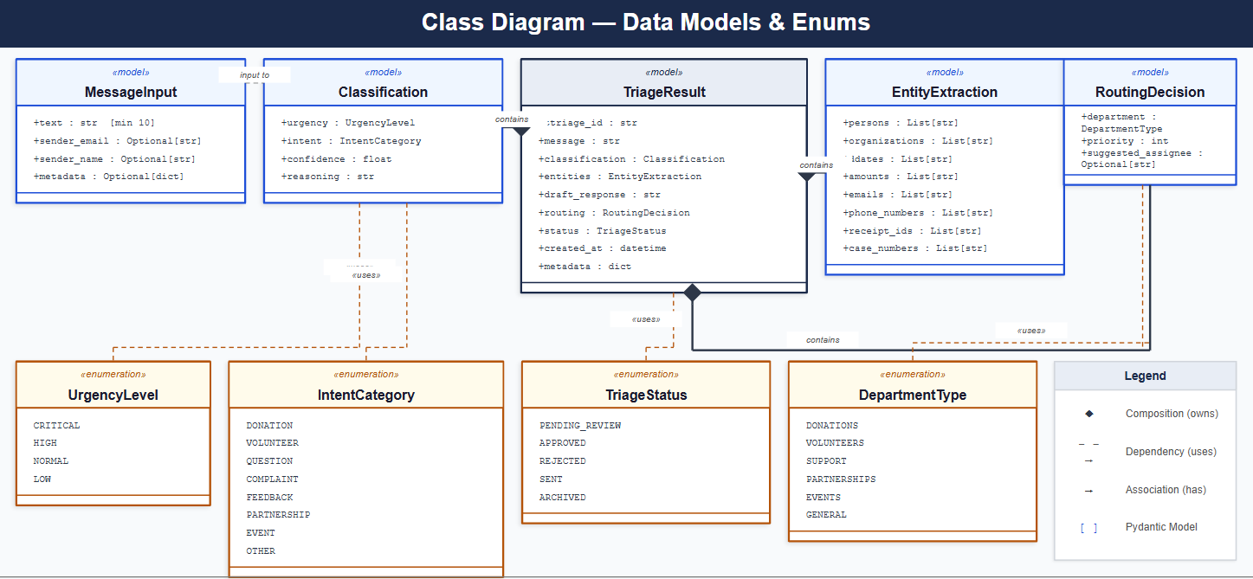

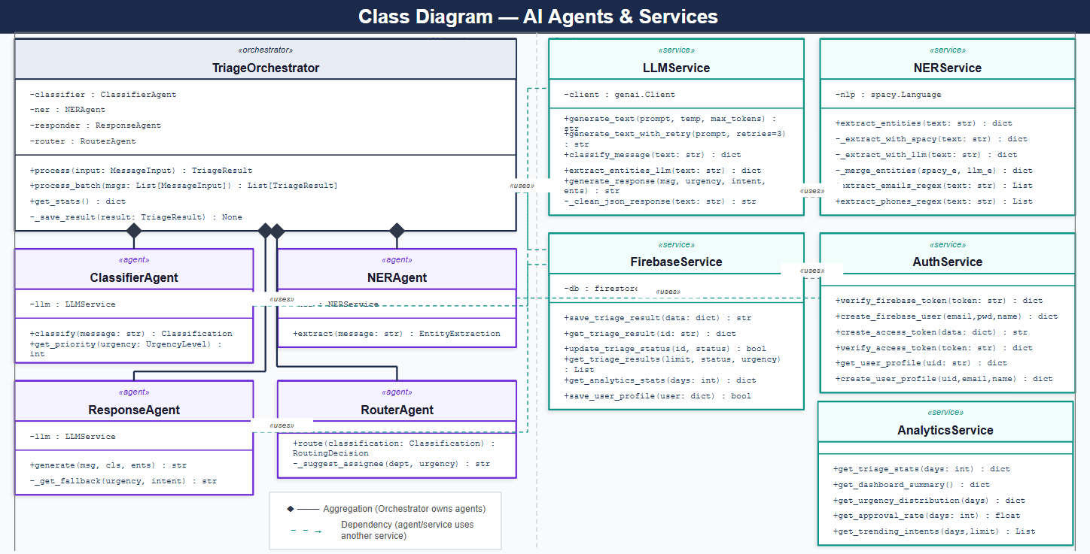
  - Components Design
    - Backend Components Design
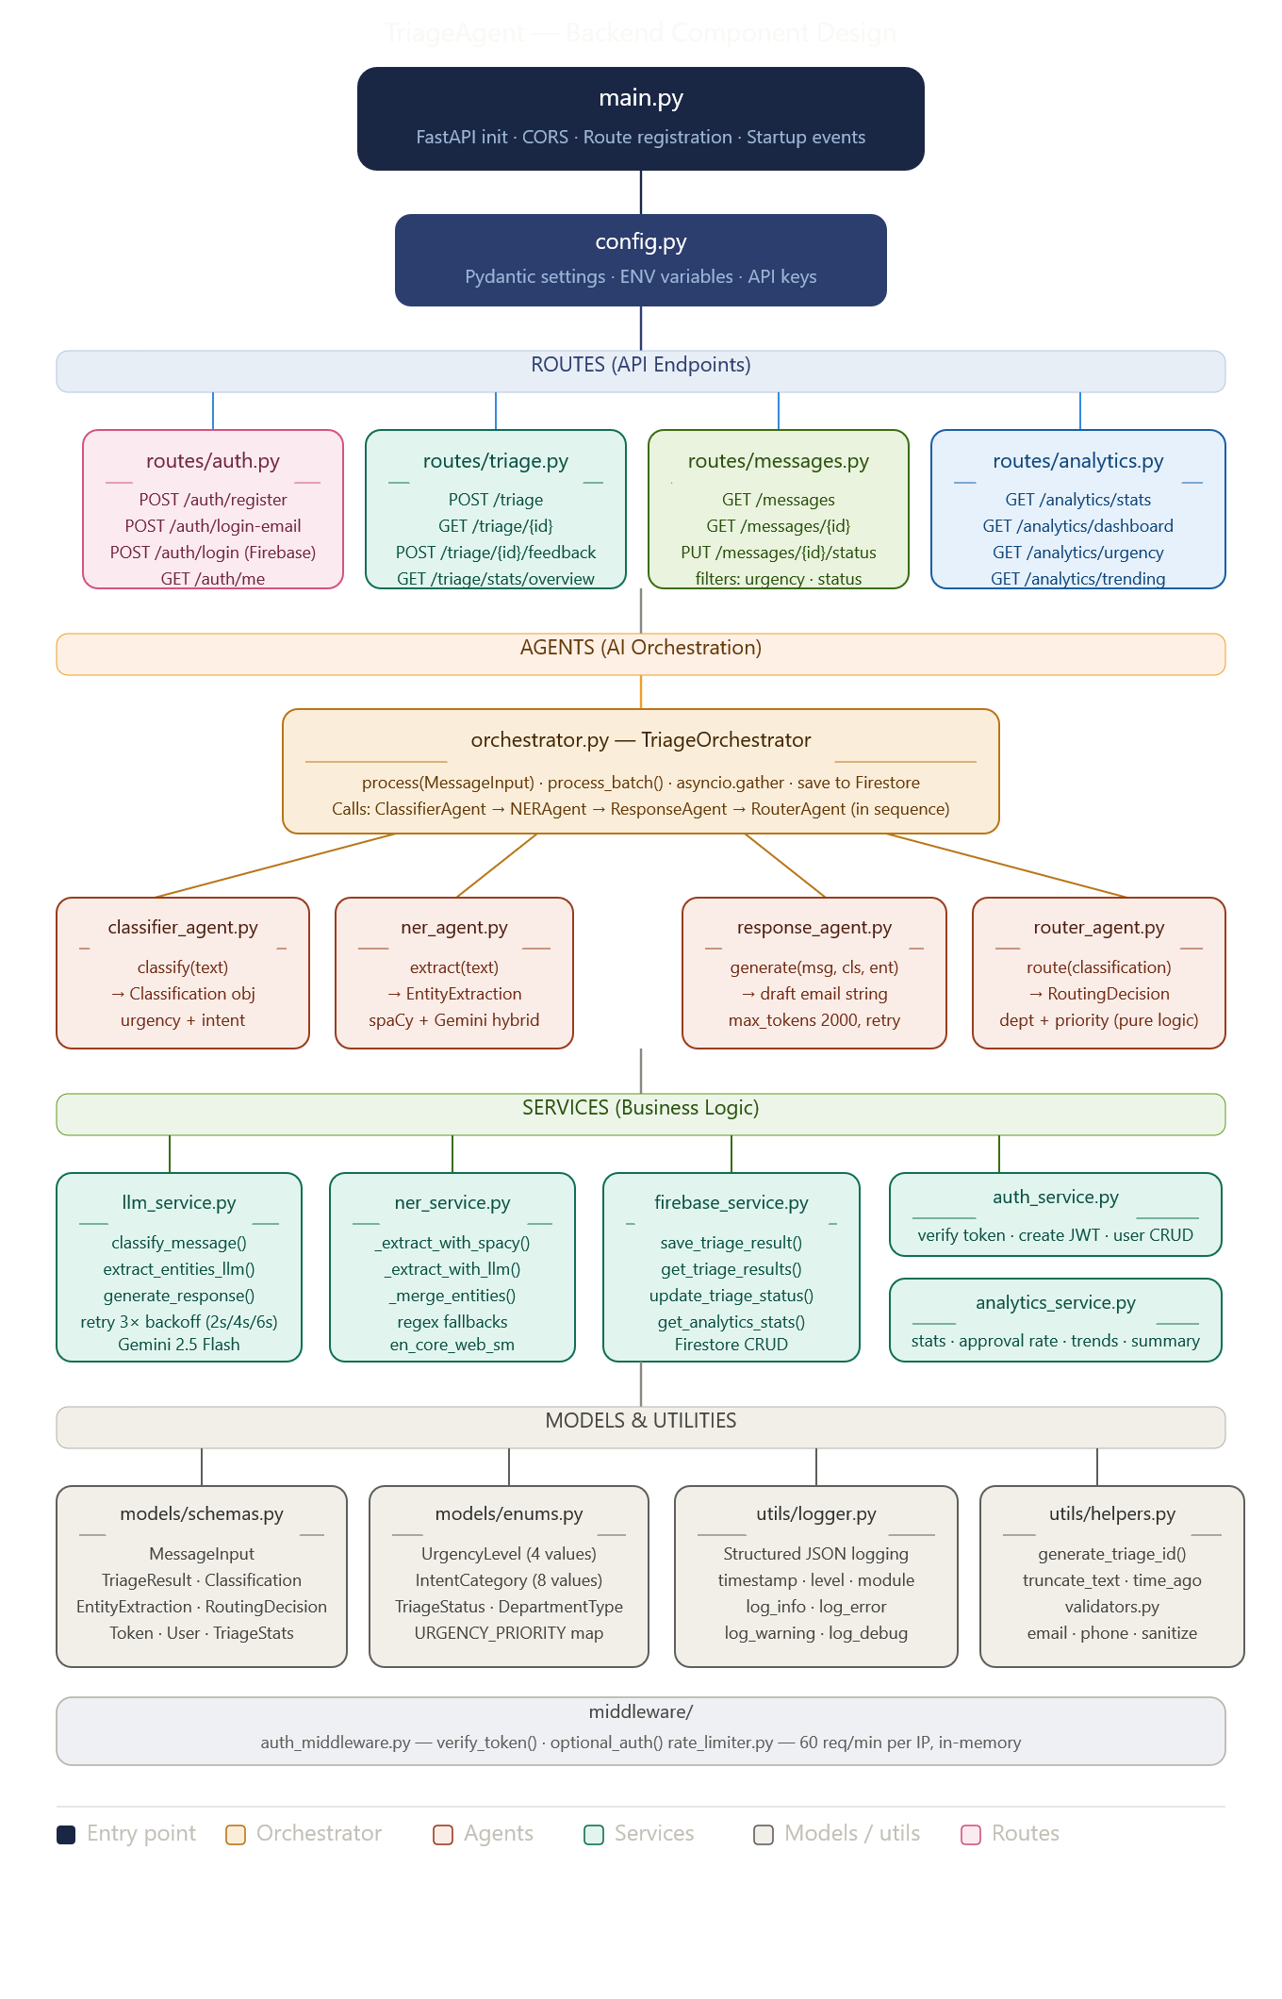

    - Frontend Components Design
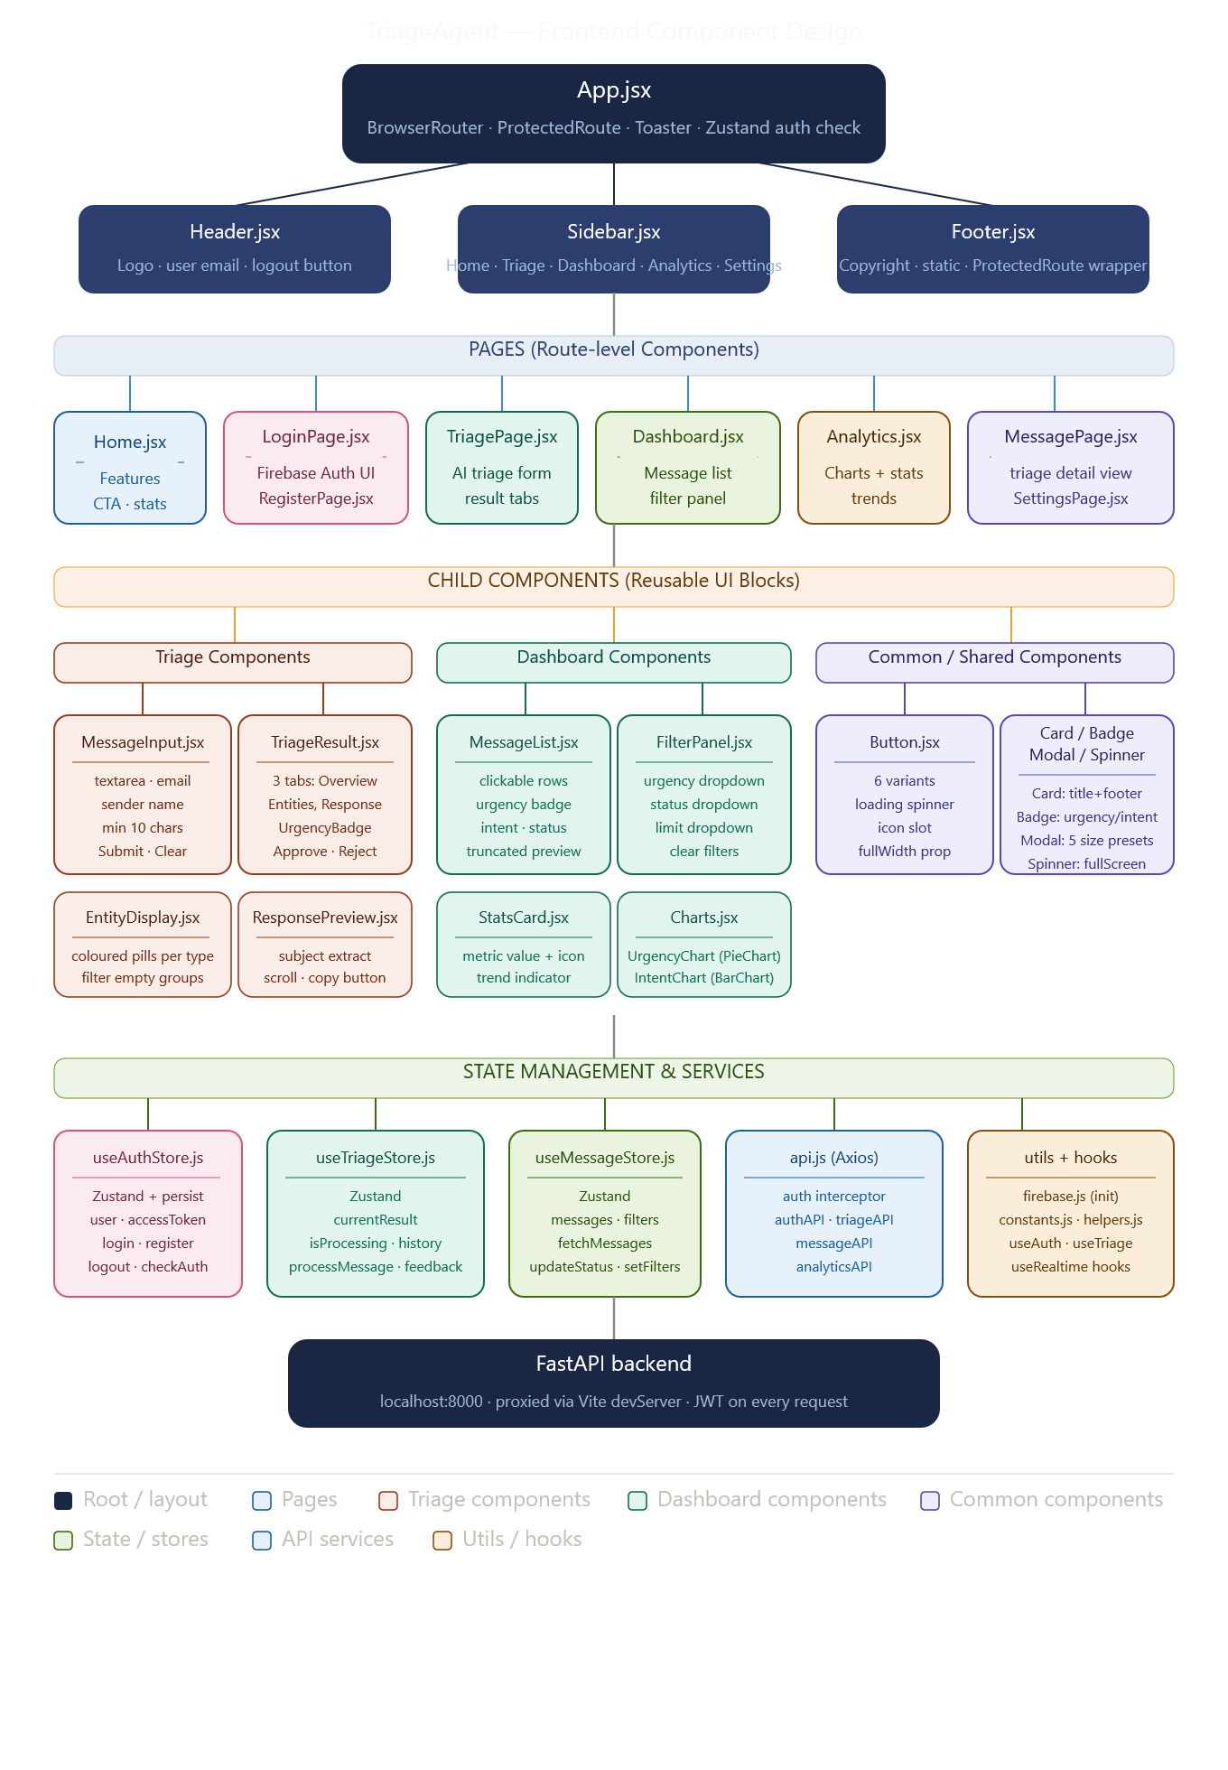

  - Key Design Considerations

No. | Design Consideration | Description | Why This Choice Was Made
1 | Hybrid NER Approach | Combined two methods for entity extraction: spaCy for fast offline extraction (names, dates) and Gemini LLM for context-aware extraction (receipt IDs, emails, case numbers). | spaCy alone misses domain-specific entities, while LLM-only solutions are slower and costlier. A hybrid approach provides both speed and accuracy.
2 | LangChain over CrewAI | Used LangChain as the framework to build and manage the agent pipeline. | LangChain provides strong tool integration, prompt management, and pipeline control, making it easier to orchestrate tasks and integrate LLM workflows compared to CrewAI for this project.
3 | Multi-Agent Architecture | The system is divided into four specialized agents: Classifier Agent, NER Agent, Response Agent, and Router Agent coordinated by an Orchestrator. | Follows the Single Responsibility Principle. Each agent performs one specific task, making the system easier to test, debug, maintain, and scale.
4 | Retry Logic for LLM Calls | Implemented retry logic for Gemini API calls, retrying up to 3 times with exponential backoff (2s → 4s → 6s). | Gemini APIs sometimes return 503 errors (overloaded). Retry logic ensures the system recovers automatically instead of failing.
5 | Human-in-the-Loop | AI generates the response, but a human must approve it before sending. | LLMs may produce hallucinated or incorrect responses. Human review ensures accuracy, empathy, and reliability, especially important for non-profit communication.
6 | Firebase over SQL Database | Used Firebase Firestore (NoSQL) instead of PostgreSQL or SQLite. | Firestore requires no server management, offers automatic scaling, has a free tier suitable for MVP, supports real-time updates, and integrates easily with Firebase Authentication.
7 | JWT + Firebase Auth Dual Token System | Authentication handled by Firebase Auth, while JWT tokens are used for backend API access. | Firebase securely manages user credentials, while JWT allows stateless API authentication, avoiding repeated Firebase verification calls and improving performance.

  - API Catalogue

Base URL: http://localhost:8000 | Auth: Authorization: Bearer {JWT} | Content-Type: application/json
Authentication APIs — /api/auth
Method | Endpoint | Description | Auth Required
POST | /api/auth/register | Register new user, create Firebase account + Firestore profile | No
POST | /api/auth/login | Login with email and password, Verify Firebase ID token, return JWT | No
GET | /api/auth/me | Get current authenticated user profile | Yes

Triage APIs — /api/triage
Method | Endpoint | Description | Auth Required
POST | /api/triage | Process message through full AI triage pipeline | Yes
GET | /api/triage/{triage_id} | Get single triage result by ID | Yes
POST | /api/triage/{triage_id} / feedback | Submit human approval or rejection with optional edited response | Yes

Messages APIs — /api/messages
Method | Endpoint | Description | Auth Required
GET | /api/messages | Get all triage messages with optional filters (urgency, status, limit) | Yes
GET | /api/messages/ {triage_id} | Get full triage result document by ID | Yes
PUT | /api/messages/ {triage_id}/ status | Update message status (approved / rejected / sent / archived) | Yes

Analytics APIs — /api/analytics
Method | Endpoint | Description | Auth Required
GET | /api/analytics/stats | Get total message count and breakdown by urgency, intent, status | Yes
GET | /api/analytics/ dashboard | Get full dashboard summary — 7d + 30d stats, trends, performance | Yes
GET | /api/analytics/ urgency | Get message distribution by urgency level | Yes
GET | /api/analytics/intent | Get message distribution by intent category | Yes
GET | /api/analytics/ performance | Get avg/min/max processing times and approval rate | Yes

- References
# | Reference | URL / Source
1 | FastAPI Official Documentation | https://fastapi.tiangolo.com/
2 | LangChain Documentation | https://python.langchain.com/docs/
3 | Google Gemini API Documentation | https://ai.google.dev/gemini-api/docs
4 | spaCy NLP Documentation | https://spacy.io/usage
5 | Firebase Firestore Documentation | https://firebase.google.com/docs/firestore
6 | Pydantic V2 Documentation | https://docs.pydantic.dev/
7 | React 18 Documentation | https://react.dev/
8 | Tailwind CSS Documentation | https://tailwindcss.com/docs
9 | Zustand State Management | https://github.com/pmndrs/zustand
10 | Project GitHub Repository | https://github.com/anushkakashyap31/TriageAgent

Technology Stack — TriageAgent
The following table specifies every technology used, its version, its role in the system, and the justification for choosing it over available alternatives.
Backend
# | Category | Technology | Version | Purpose | Justification
1 | Backend Framework | FastAPI | 0.109.0 | REST API server — all routes, middleware, CORS, startup events | Fastest Python web framework (ASGI). Native Pydantic integration for request validation. Chosen over Flask/Django for async support and auto-generated API documentation.
2 | Runtime | Python | 3.11.0 | Backend language for all agents, services, and API logic | Required by spaCy and LangChain ecosystem. Python 3.11 brings significant performance improve.
3 | ASGI Server | Uvicorn | 0.27.0 | Runs the FastAPI app in development and production | Lightweight, production-ready ASGI server. Supports hot-reload in development.
4 | Data Validation | Pydantic V2 | 2.5.3 | Schema validation for all API request/response models | Pydantic V2 is 5–50x faster than V1. Strict type enforcement at API boundary.

AI / LLM
# | Category | Technology | Version | Purpose | Justification
5 | LLM API | Google Gemini 2.5 Flash | google-genai 1.46 | Message classification, entity extraction, draft response generation | Free tier available for MVP development. Fast inference speed suitable for real-time triage.
6 | Agent Framework | LangChain | 0.2.17 | LLM chain management, prompt templates, output parsers, agent orchestration | More control over custom triage logic than CrewAI. Flexible for single-pipeline orchestration. Supports prompt templates with structured output parsing.

NLP / Named Entity Recognition
# | Category | Technology | Version | Purpose | Justification
7 | NLP / NER | spaCy | 3.7.2 | Offline entity extraction — names, dates, organizations, money amounts | Runs offline with zero API cost — milliseconds per request. en_core_web_sm is accurate for standard English entities. Hybrid with Gemini gives best accuracy. spaCy alone misses domain-specific IDs; Gemini alone is slow and costly for every call.

Database
# | Category | Technology | Version | Purpose | Justification
8 | Database | Firebase Firestore | firebase-admin 7.2 | NoSQL document store for triage results, user profiles, analytics stats | No server management required. Scales automatically on Google infrastructure. Free tier sufficient for MVP. Real-time listeners available for future live dashboard. Direct integration with Firebase Auth.

Authentication & Authorization
# | Category | Technology | Version | Purpose | Justification
9 | Authentication | Firebase Auth | firebase-admin 7.2 | User registration, login, password hashing, credential management | Handles password hashing and storage securely. Supports email/password. Integrated with Firestore same project credentials. Breach detection and security monitoring built-in.
10 | API Authorization | JWT (python-jose) | 3.3.0 | Stateless API access token issued after Firebase login | Stateless backend — no session storage needed. JWT verified on every API request without hitting Firebase. Enables Postman / API testing without Firebase SDK.

Frontend
# | Category | Technology | Version | Purpose | Justification
11 | UI Framework | React 18 | 19.2.0 | Admin dashboard — triage interface, message review, analytics | Component-based architecture suits dashboard with reusable UI blocks. Virtual DOM ensures fast re-renders for real-time triage results. Huge ecosystem of libraries.
12 | Build Tool | Vite | 7.3.1 | Dev server, hot module replacement, production bundler | Significantly faster than Create React App. Hot module replacement in milliseconds. Built-in proxy for /api calls eliminates CORS issues in development.
13 | CSS Framework | Tailwind CSS | 3.4.1 | Utility-first styling for all components | Rapid UI development with utility classes. No context-switching between CSS files. Consistent design system. Used Tailwind v3 for PostCSS compatibility with Vite.

State Management & HTTP
# | Category | Technology | Version | Purpose | Justification
14 | State Management | Zustand | 5.0.11 | Global state for auth, triage results, message list, filters | Minimal boilerplate compared to Redux. Three isolated stores (Auth, Triage, Message) prevent state coupling. Built-in persist middleware syncs accessToken to localStorage.

